**Variables**

Variables is something that makes computer program very useful by storing information in memory.

While creating variables in JAVA we need to assign two things. First is the type of information we want to store and second is the name of the variable. Below is an example of variable where int is a type of information (integer in this case) and x is the name:

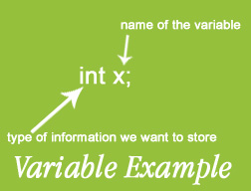

Here int is integer primitive data type and x is the variable.